Graphical-budget-planner 1.7.0
Quick Tutorial
version : 2025-11-29 18:07:19

What you have to know before hand
- Future-focused : Graphical-budget-planner focuses on future projections only. It does NOT track/process past incomes/expenses.
- How it works: You define income/expense items (called “Cash Stream Definitions, a.k.a. CSD), which automatically generate financial events (specific amounts on specific dates). These events generate a "Cash Balance Curve"—a visual projection of your future balance.
- Scenarios : Income/expense definitions are organized into "scenarios" (JSON files). You can have many scenario files, but only one is active at a time.
- Analysis module : Use Tools → Analysis to view statistics, distributions, and summaries of your financial events.

Interacting with the Cash Balance Curve
- Zoomed in/out with the mouse scroll wheel. 3 types of zoom operations are possible :
  - Scroll wheel alone : both horizontal and vertical zoom
  - Scroll wheel + SHIFT : horizontal zoom only
  - Scroll wheel + CONTROL : vertical zoom only
- Pan in any direction: Click and drag on the chart with the left mouse button.
- Pan left/right by window: Use the "<" and ">" toolbar buttons to move one full window width.
- Reset scale: Click the "predefined scales" toolbar buttons to quickly reset to standard zoom levels

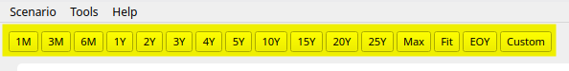
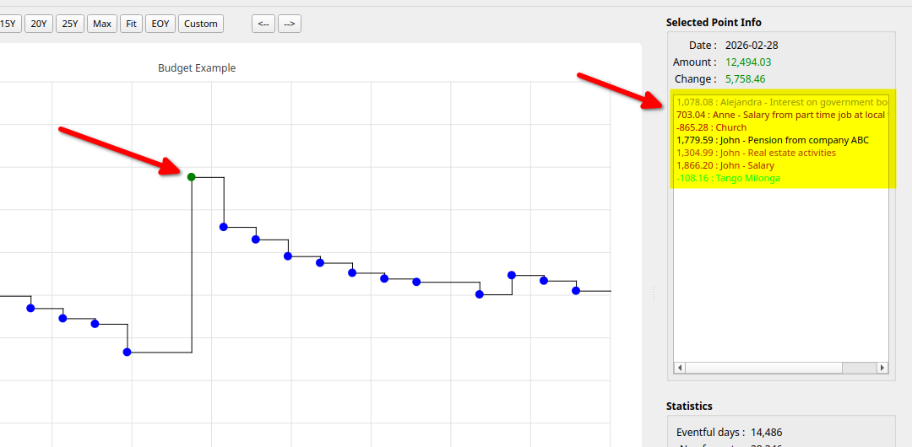
- Click on a data point : The point highlights (green by default), and the right panel shows details including all financial events that occurred on that day. The displayed amount is the previous day's balance plus all transactions for that day.

Creating a new scenario
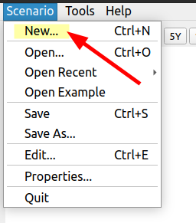

A) Select the “Scenario -> New...” menu

B) Choose the currency to be permanently associated to this new scenario, by selecting a country (1), then press Select button (2) . The new scenario will be created, with empty data. It becomes the “current scenario”.

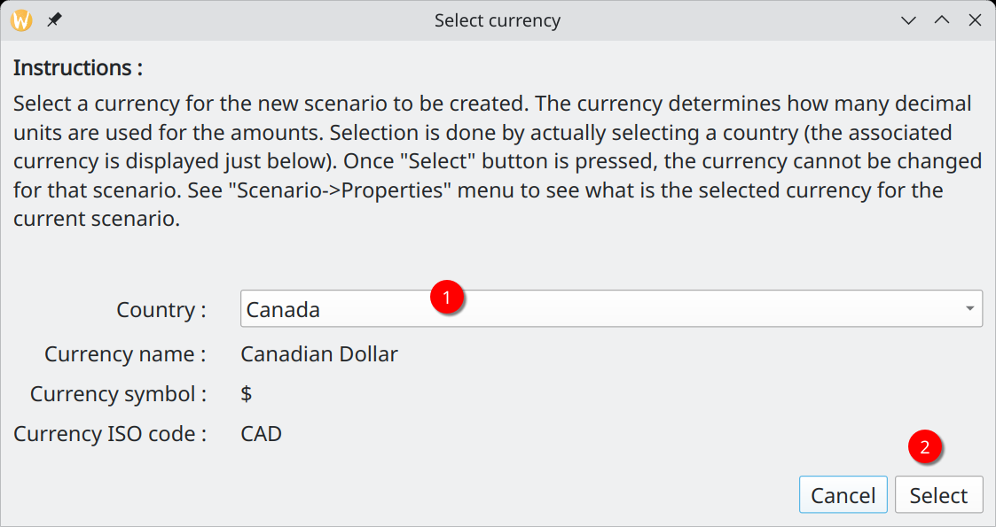

C) Edit the data (1,2,3,4) related to the new scenario. When finished, press “Apply Changes” button (5).

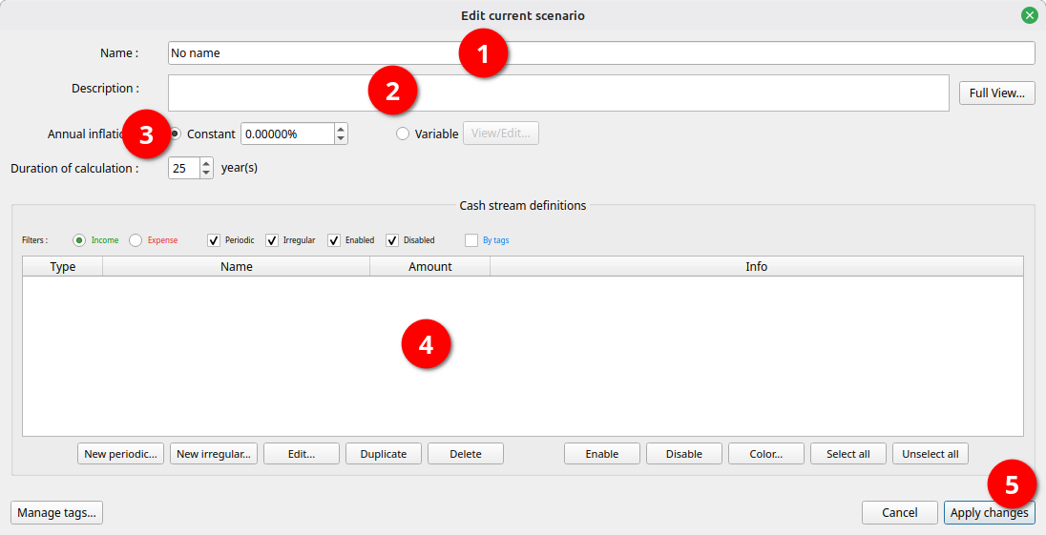
(C-1) : Give name to the scenario (this is NOT the file name)
(C-2) : Optionally enter a descriptive text.
(C-3) : Define an annual inflation, to be optionally used later in the process of defining incomes/expenses. Leave to default if you don't want to use inflation (0 %).

(C-4) Define all the incomes / expenses you need in the scenario. There are 2 types of each :

Type | Use When | Examples
Periodic | Amounts repeat at regular intervals | Salary, rent, mortgage, insurance
Irregular | One-time or sporadic transactions | Bonus, gift, car repair, renovation

“Periodic” Income / Expense :

Use for amounts that repeat at regular intervals. Press "New Periodic" to create one, or "Edit" / double-click to modify an existing one.

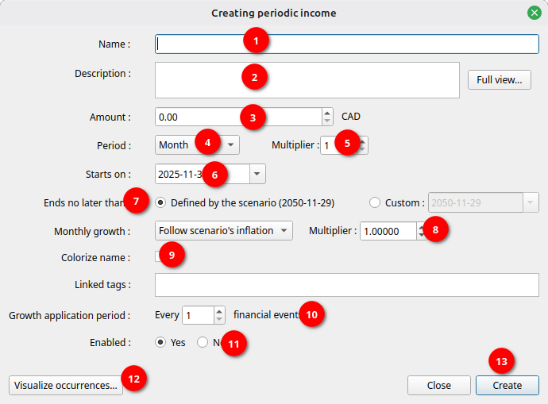
(1) : Give a name. All UNICODE characters are allowed. Limit of 100.
(2) : Optional description. All UNICODE characters are allowed. Limit of 4000.
(3) : The amount to be repeated.
(4) & (5) : The periodicity of the repetition. End-of-month force all the financial events to occur at end of month.
(6) : Date of the first event generated for this Periodic Cash Stream Definition.
(7) : End date after which no more event can occurred for this Periodic Cash Stream Definition.
(8) : Define an optional growth pattern to be applied to the amount. See the User Manual.
(9) : Optionally apply a color to the name of this income/expense.
(10) : Advance use, leave to default value if you don’t know how to use it. See the User Manual.
(11) : Should this income / expense be enabled or not ?
(12) : See the effects of all the parameters defined in the form on the financial events generated.
(13) : Create the income / expense by pressing “Create”. The window will stay there in case you want to create another one right after. Press “Close” to terminate the Edit process.

“Irregular” Income / Expense :

Use for one-time or non-recurring amounts where you manually specify each occurrence date and amount. Press "New Irregular” to create one, or "Edit" / double-click to modify an existing one.

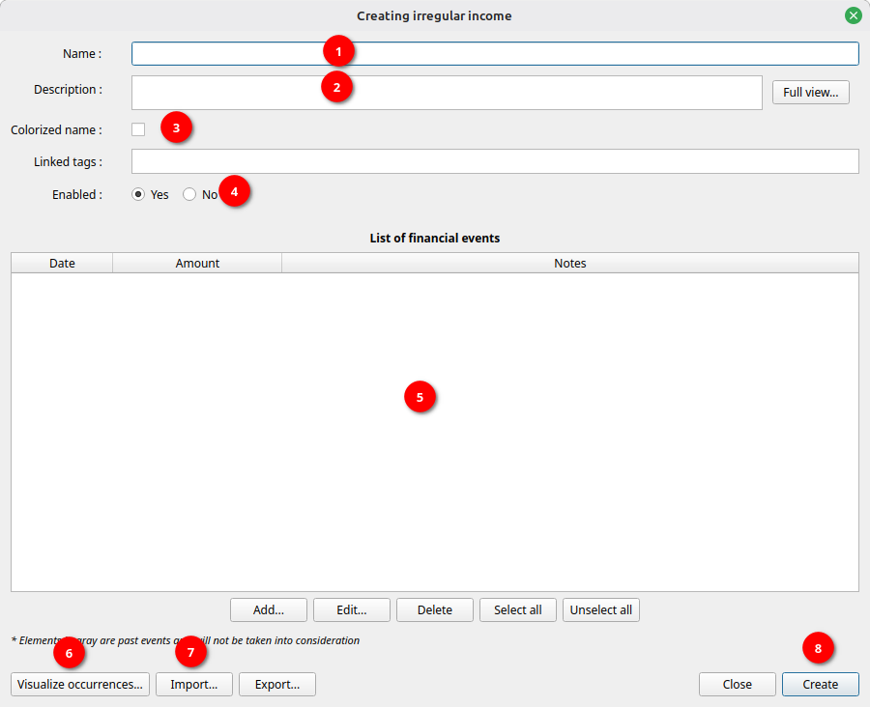
(1) : Give a name. All characters are allowed. Limit of 100.
(2) : Optional description.
(3) : Optionally apply a color to the name of this income/expense.
(4) : Should this income / expense be enabled or not ?
(5) : Add / Delete / Modify individual specific amounts along with the dates of occurrence. This could for example look like this:
(6) : See the effects of all the parameters defined in the form on the financial events generated..
(7) : You have the option to import the data from a CSV file instead of entering them manually.
(8) : Create the income / expense by pressing “Create”. The window will stay there in case you want to create another one. Press “Close” to terminate the Edit process.

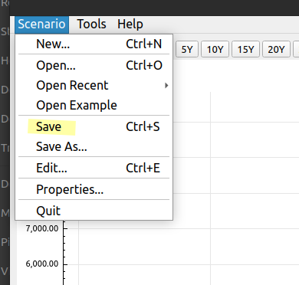

D) Save the scenario into a file if you want the new scenario to be used later

Opening an existing scenario

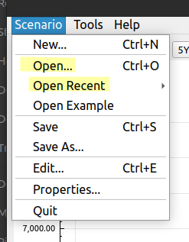

A) Open an existing scenario file using the “Scenario->Open” or “Scenario->Open Recent”

B) Enter the total current cash asset you have as of today. You determine this amount by your own means, e.g. looking at your bank accounts. The Cash Balance curve will start from this amount. This is NOT saved in the scenario file.
You will then see the calculated cash balance curve, derived from all the financial events generated.
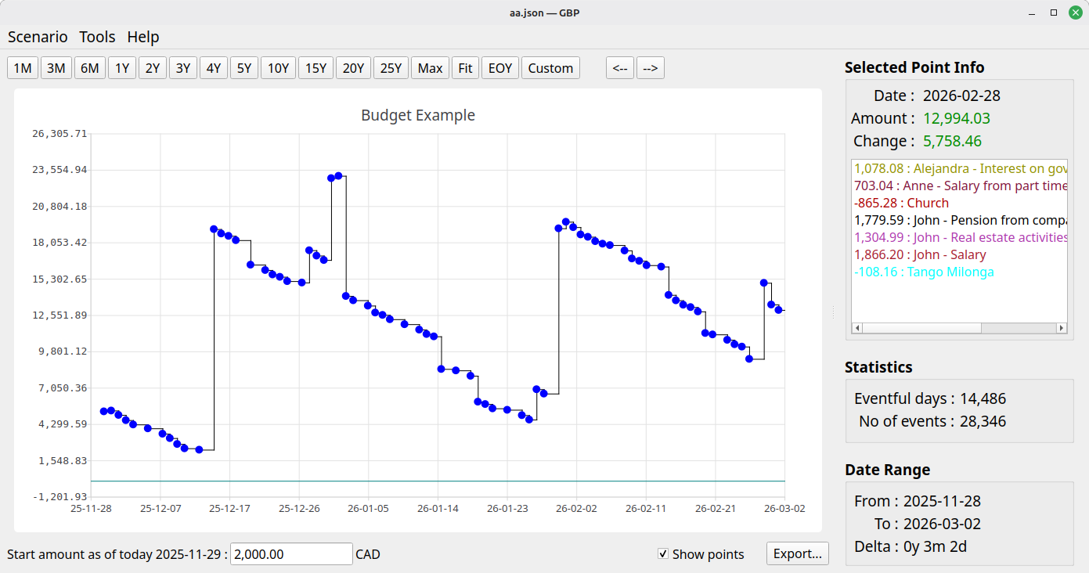

Editing an existing scenario
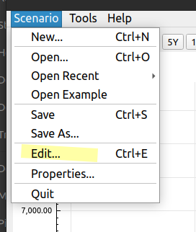
A) Once a scenario is opened, select “Scenario->Edit” menu to bring the same window seen previously in the “Create Scenario” section

B) Do all the editing required. Everything can be changed, except the currency.

C) Once completed, press “Apply Changes” to update in memory the currently loaded scenario and thus see updates applied to the displayed cash balance curve.

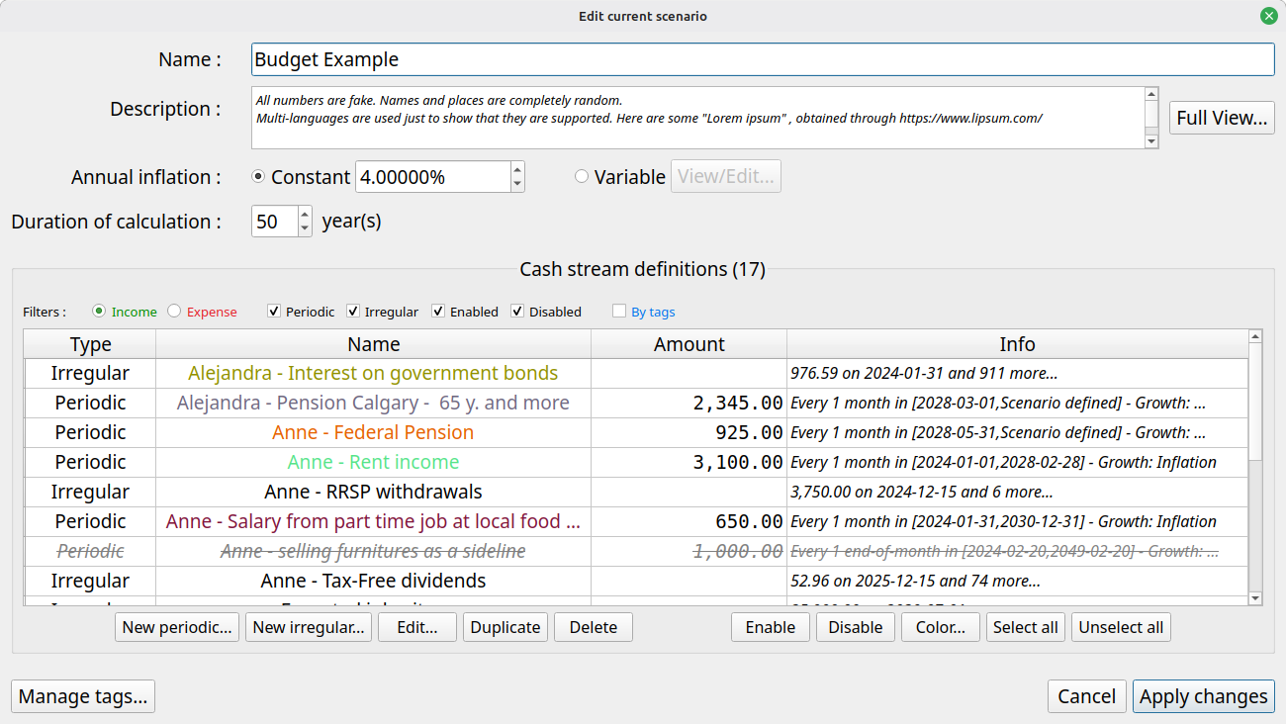
D) To save permanently the modifications made to the scenario, you have to explicitly save it using the “Scenario->Save” menu. Otherwise all changes will be lost when you exit graphical-budget-planner.

Using Tags to categorise income/expense Cash Stream Definitions
Tags help you organize and categorize your income and expense CSDs. You can assign one or more tags to each CSDs, making it easier to filter, analyze, and manage your financial data.

Creating and Managing Tags:
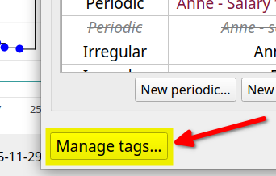
- Use the "Manage Tags" button to create new tags for your scenario or assign them to CSDs
- Examples: "Essential", "Discretionary", "Work", "Medical", "Housing"

Using Tags in Analysis:
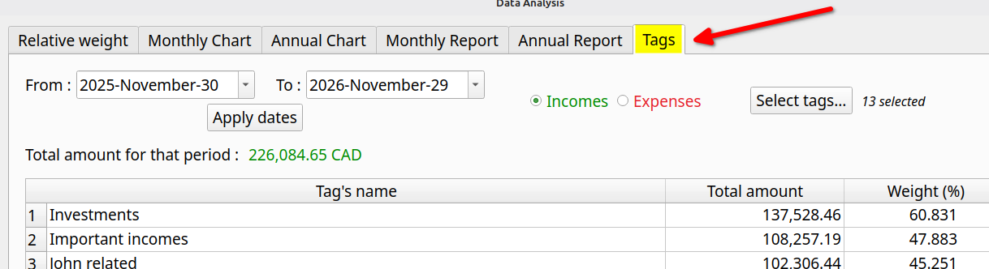
The Analysis module allows you to filter and view financial events by tags, making it easy to see spending patterns for specific categories or understand the impact of tagged CSDs on your overall budget.

Analyzing a scenario
This module, available through the “Tools->Analysis” menu, provides a lot of statistical info about the financial events generated, including :
- the super useful distribution of incomes/expenses by weight (which are the most significants over a certain period of time)
- Monthly and yearly summaries, both in histogram form and exportable tabular form.

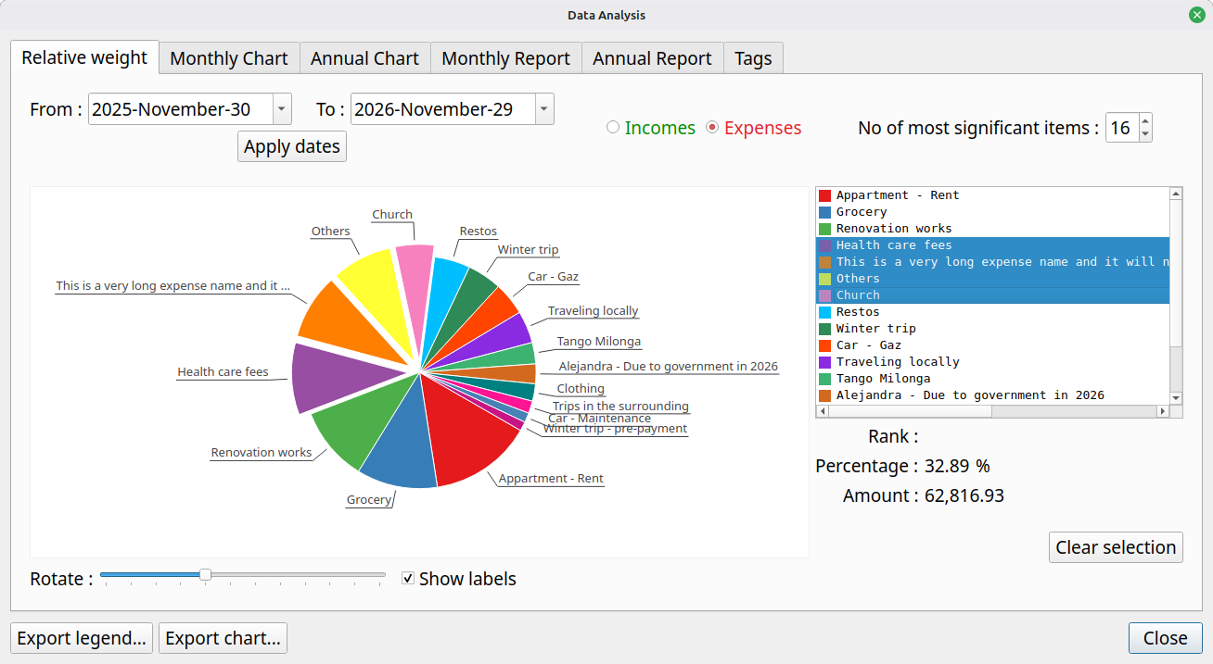

To get more information
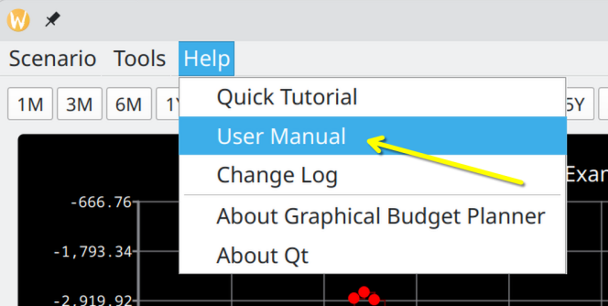
See the User Manual (english version only), which provides a great deal of details on every aspect of graphical-budget-planner.

